Forecasting bike hire trips

In this exercise, we want to forecast the number of bike hire trips starting from Metro Mont Royal to Berri stations, in the city of Montreal, Quebec, Canada.

The goal is to provide one week worth of daily forecasts, using any methods and models (statistics, econometrics, or a combination of those) which could prove useful.

In the context of this exercise, it is not necessary to look for external data such as weather forecasts, public works announcements or exceptional events. Please use only the data provided by the Bixi website, as mentioned below.

In addition to the forecasting itself, please provide a brief note including a reasonable explanation of the methods and the strategy you used. Please also submit your Python source code. From the date we sent you the case study, you will have 1 week to complete and submit your answer.

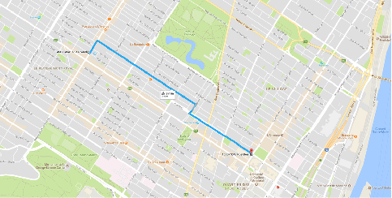

1. Go to Bixi’s website ( <https://www.bixi.com/en/page-27> )
2. Download trip history for years 2014 to 31 August 23:59:59 2017
3. Provide a daily forecast of the following trips:

* from station 6184 to station 6015
* from September 4th 00:00:00 to September 10th 23:59:59
* if advisable, break down the forecast by member / not member